

The Superior University

|  |  |  |
| --- | --- | --- |
| Name: Abdul Moeez | Roll No: 017 | Course: PAI Lab |
| Semester: 4th | Section: BSAI 4A | Department: Artificial Intelligence |
| Submitted To: Sir Rasikh | Total Marks: | Date: |

**Lab 6**

**Face Detection and Feature Estimation Using OpenCV**

### **Introduction:**

This document explains the purpose and functionality of the provided Python script, which utilizes OpenCV to detect faces in an image and estimate the locations of facial features such as the eyes, nose, and mouth.

### **What the Code Does:**

1. **Imports Required Libraries:**
   1. cv2 for image processing
   2. numpy for numerical operations
   3. matplotlib.pyplot for displaying images
2. **Loads a Pre-Trained Face Detector:**
   1. Uses OpenCV’s Haar Cascade classifier for frontal face detection.
3. **Loads and Prepares an Image:**
   1. Reads an image file (face.jpg).
   2. Converts it to grayscale for better detection accuracy.
4. **Detects Faces:**
   1. Uses detectMultiScale() to find faces in the image.
   2. Adjusts parameters like scaleFactor and minNeighbors for accurate detection.
5. **Draws Rectangles Around the Detected Face and Features:**
   1. Identifies approximate regions for the **eyes, nose, and mouth** using proportional calculations.
   2. Uses cv2.rectangle() to highlight these regions.
6. **Displays the Processed Image:**
   1. Converts the image to RGB format.
   2. Displays it using matplotlib.

### **OUTPUT:**

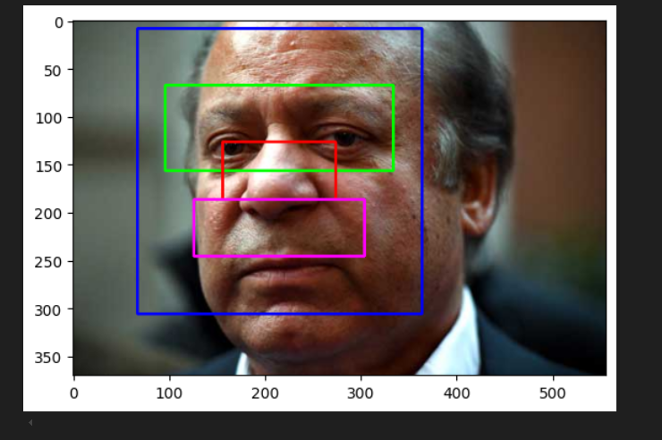

### **Why This Code is Useful:**

* **Facial Recognition Preprocessing:** Helps detect and locate facial features for further processing.
* **Computer Vision Applications:** Used in security, biometric authentication, and social media filters.
* **Education & Research:** Demonstrates OpenCV’s face detection capabilities in a simple way.